STRICTLY PRIVATE & CONFIDENTIAL
DATED 2026

PROJECT [ ]

____________________________________
Draft 1
INFORMATION MEMORANDUM
____________________________________

Name of Recipient:
Date of Issue:
Copy Number:

IMPORTANT NOTICE
This Information Memorandum (“Information Memorandum”) is being issued by Scalper Limited (the “Company”) to a limited number of parties in connection with the possible issue of ordinary shares in the Company (“Ordinary Shares”)
The information contained in this Information Memorandum is prepared to [ ] 2007 and does not take account of any developments after that date. It does not purport to contain all the information that you may require. No obligation is accepted to provide you with access to any additional information, or to update, expand, revise or amend the information, or to correct any inaccuracies which may become apparent. You should conduct your own investigation and analysis of the Company and other companies in the group and of the information contained in this Information Memorandum. You are advised to seek your own professional advice on the legal, financial, taxation and other consequences of acquiring Ordinary Shares to be issued by the Company.
This Information Memorandum may include certain statements, estimates and projections with respect to the anticipated future performance of the Company and as to the market for the Company’s services and products. Such statements, estimates and projections reflect various assumptions made by the management of the Company concerning anticipated results, which assumptions may or may not prove to be correct. No representation is made as to the accuracy of such statements, estimates and projections.
This Information Memorandum is being issued by the Company. It is a condition of the issue of this Information Memorandum that the recipient will not issue, cause to be issued, or make this Information Memorandum available to anyone else other than as mentioned above.
This document is being distributed to, and are directed only at, and may only be communicated to persons in the United Kingdom and who are (i) existing shareholders (ii) relevant professionals defined in article 19 of the financial services and Markets Act 2000 (Financial Promotions) Order 2005 (“Order”) (iii) certified and High Net Worth Individuals as defined in article 48 or (iv) self-certified sophisticated investors as defined in article 50A of The Order, together being referred to as “relevant persons”.
This document is being distributed to, and is only directed at relevant persons and must not be acted on or relied upon by persons who are not relevant persons. Accordingly, this document is exempt from the general restriction on the communication of invitations or inducements to enter into investment activity and has not therefore been approved by an authorised person, as would otherwise be required by section 21 of the Financial Services and Markets Act 2000 (as amended) (“FSMA”). Any investment or investment activity to which the final form of this document relates is available only to relevant persons and will be engaged in only with relevant persons. Any person in receipt of this document who is not a relevant person should return it immediately to the Company at its registered office. It is a condition of your receiving this document that you are, and you represent and warrant to the Company that you are, a relevant person.
This document is being provided to recipients on the basis that the keep confidential any information contained in it or otherwise available, whether orally or in writing, in connection with the Company. This document and its contents are confidential and must not be copied, reproduced, published, disclosed, distributed or passed to any other person (in whole or in part by any medium or in any form, at any time) for any purpose other than to professional advisers for the purposes of advising a relevant person. The distribution of this document and the offering of Ordinary Shares in certain jurisdictions may be restricted by law and therefore persons into whose possession this document comes should inform themselves about and observe any such restrictions. Any failure to comply with these restrictions may constitute a violation of the securities laws or any such jurisdiction.
The Ordinary Shares have not been, and will not be, registered under the United States Securities Act 1933, as amended (the “Securities Act”), or under the securities legislation of any state of the United States, Australia, Canada, Japan or the Republic of Ireland. Accordingly, subject to certain exceptions, the Ordinary Shares may not, directly or indirectly, be offered within the United States except pursuant to an exemption from, or in a transaction not subject to, the registration requirements of the Securities Act and, subject to certain exceptions, may not be offered or sold within Australia, Canada, Japan or the Republic of Ireland or to or for the account or benefit of any national, resident or citizen of Australia, Canada, Japan or the Republic of Ireland or any person located in the United States. This document does not constitute an offer, or the solicitation of an offer to subscribe or buy, any of the Ordinary Shares to any person in any jurisdiction to whom it is unlawful to make such offer or solicitation in such jurisdiction and neither this document not any copy of it may be sent or taken into the United States, Australia, Canada, Japan or the Republic of Ireland nor may it be distributed to any US person (within the meaning of Regulation S).
If you are in any doubt as to the contents of this Information Memorandum or the action that you should take, you should consult your stockbroker, bank manager, accountant, solicitor or other independent financial adviser duly authorised under the FSMA who specialises in advising on the acquisition of shares and other securities if you are in the United Kingdom, or, if not, from another appropriately authorised financial adviser in your own jurisdiction.
A prospective investor should be aware of the risks of investing in the Company and should make the decision to invest only after careful consideration and, if appropriate, consultation with an independent financial adviser. No application is being made or is intended to be made for the admission of the Ordinary Shares to trading on PLUS Markets, AIM or any other market.
The whole of this document should be read. An investment in the Company involves a significant degree of risk, may result in the loss of the entire investment and may not be suitable for all recipients of this document. The attention of investors is drawn in particular to the risk factors set out in this Information Memorandum.
This Information Memorandum does not comprise a prospectus and has not been drawn up in accordance with the Prospectus Rules 2005.

INDEX

SECTION 1 - COMPANY SUMMARY 7
1.1 Company Overview 7
1.2 Key Product 8
1.3 Revenue Model 10
1.4 Use of Proceeds 10
1.5 Marketplace 12
Competition 14
Directors 15
SECTION 2 - FINANCIAL INFORMATION 16
2.1 Important note 16
2.2 Summary historical and projected figures 16
2.3 Notes regarding historical and projected financial figures 16
2.4 Observations on the financial data 17
2.5 Valuation estimate 18
Balance Sheet statements - actuals 20
Profit and Loss statements - actuals 21
Projected profit and loss statements to Dec 07 22
Projected profit and loss statements, Jan 08 – Dec 08 23
Projected cash-flow statements to Dec 07 24
Projected cash-flow statements, Jan 08 – Dec 08 25
Projected Balance Sheet statements to Dec 07 26
Projected Balance Sheet statements, Jan 08 – Dec 08 27
SECTION 3 – STATUTORY COMPANY INFORMATION 1
SECTION 4 - PROCEDURE FOR APPLICATION 2
APPENDIX – MATERIAL CONTRACT 3
APPENDIX: KEY ENTITIES 4
BGC FX (www.bgcfx.com) 4
Currenex (www.currenex.com) 4
Tradestation (www.tradestation.com) 4
Appendix: Franco Dimuccio 5
Appendix: Roadmap to Dec 2007, as at April 07 6
Appendix: Risks, Evaluation & Mitigation 7
Appendix: London and the global FX market 8
Appendix: Extracts from e-Forex Magazine, April 2007 9
Appendix: End-user marketing 11

SECTION 1 - COMPANY SUMMARY

1.1 Company Overview

Scalper Limited’s (Scalper) software product, Tradecompanion, has just been launched by its new trading partner, BGC FX, (BGC) which with a monthly trading volume of billions of dollars and rising (the exact figures are confidential) is a substantial and one of the world’s most respected foreign exchange (FX) ‘Prime Brokers’.
The Director believes that within a year Scalper could, with the software technology it has already developed, be generating revenues in excess of £200,000 every month, by taking a small margin from each FX trade executed via Tradecompanion. Following appropriate product development, within two more years, the Director believes it could then be generating revenues of more than £200,000 a week.

History
Scalper was set up by Franco Dimuccio (Franco, or the Director) in 2001 to service the global foreign exchange (FX) market. He chose this market because, with daily trade volumes of over $2 Trillion, it is the biggest.
Scalper first became a reseller of third party software applications and data services, to generate a small income, get to know the market and network within it. Franco then identified an opportunity to add significant value to many of the software packages and information services serving the FX market by developing appropriate software, ‘middleware’, that could link key applications and data services together, so as to offer a superior bundled service package to traders.
Most of the last six years have been spent developing the necessary technical know-how, and creating the middleware. Franco’s networking has also paid dividends in that after its extensive trialling of the product, ‘Tradecompanion’ is now being offered to a global market by BGC through an exclusive distribution agreement as detailed in appendix.
To date Scalper has always been a one - man operation. Now that Tradecompanion has been launched Franco intends to invest in additional employees so that he has a good team about him as he seeks to grow the business further.
BGC’s ability to bundle Tradecompanion into its service package offers it an important competitive advantage when targeting the business of both institutional and retail FX traders and second tier FX brokers. Scalper benefits in return, from the quality package, brand-association and global sales channel reach of BGC.
After extensive systems testing and a ‘soft launch’ with a couple of trial clients since January 2007, the director thinks that Scalper will earn in excess of £500,000 in commissions from Tradecompanion by the end of December 2007, based upon just the existing and potential clients he is already in contact with. Revenues could then continue to grow solidly and significantly through 2008, if new customers apply to and are then cleared to do business, as all clients are likely to do more of their business through the product over time, and as Tradecompanion’s is developed further so as to attract more traders to it.

Future
Over the next several months Scalper will focus on building it and BGC’s business by developing the capability and competitiveness of Tradecompanion and working to secure new trading clients
Thereafter the director’s overriding aim is to transform Scalper in to a sustainable, high-growth, multi-product financial systems and data services business with an intercontinental financial services clientele.
In 6 to 9 months, with the support of the increasing market knowledge, revenue income, shareholder investment, advisors and support staff it will have by then gained, Scalper will conduct a thorough review of its longer-term strategic options.
Milestones already on Scalper’s longer-term development roadmap, which is subject to a successful fundraising round, include inviting up to four non executive directors who can help add value to the business to its board, and listing Scalper on the PLUS markets.

Key Product

Tradecompanion: Foreign exchange trading ‘middleware’
Scalper’s foreign exchange trading application, ‘Tradecompanion’, allows foreign exchange traders to trade with the aid of their analytical computer software automatically, with only indirect human intervention. In so doing it greatly reduces the amount of time that they have to spend in front their trading screens, in a global market that operates 24 hours per day, 6 days per week. By auto-executing trades according to the complex parameters that have been pre-set by the trader, Tradecompanion also delivers a valuable time advantage, as it can react far-faster to incoming market data than any human can, and in volatile market situations with multiple trades potentially worth millions of dollars, milliseconds matter.
Within the vast and complex FX market there are other auto-trading platforms but, through Scalper’s trading relationship with BGC, Tradecompanion is currently unique in the prime-broker/institutional FX trader level. In layman’s terms, it is currently unique as a piece of middleware that links assorted ‘best of breed’ software used by many FX traders to calculate their trades to a ‘best of breed’ electronic marketplace, where many banks and other financial institutions are connected together, for a speedy execution of trades.
It currently ties backwards into Currenex,in this case as ‘white labelled’ by BGC FX and forwards into what will become a growing array of software ‘front ends’ favoured by the class of traders that BGC FX targets. The first of the serviced front ends are Tradestation (See key entities appendix) 2000i and 8.2. Connectivity to other front ends, including Metatrader, Wealthlab, eSignal and many others is already under development.
To get to where it has Tradecompanion has had to undergo rigorous testing with Currenex, BGC and Tradestation. In due course the product will be developed extensively to increase both its functionality and back and front end connectivity.
Efforts are already underway, in collaboration with BGC FX to develop Tradecompanion’s back-end connectivity with eSpeed, an alternative to Currenex.
The more ‘front’ and ‘back’ end software that Tradecompanion can connect with, the greater its potential addressable market will be.

1.3 Revenue Model

Now that Tradecompanion has been launched Scalper does not intend to continue its activities as a reseller of third party software. Until such time as Scalper has grown its portfolio of software products, it will now be entirely dependent on the commissions it earns from third parties using Tradecompanion to assist with their FX transactions.
For the period of the exclusive distribution agreement with BGC FX, Scalper will be credited a small commission for every US$1million of FX trades transacted through Tradecompanion, as captured by BGC’s back end systems. BGC and Scalper will agree a specific commission structure for each trader that signs up with BGC to use Tradecompanion. The default framework being that, as the cumulative volume of each trader’s transactions passes US$1billion, the commission is reduced and as the volume passes US$3billion, it falls further. The director believes he has amply compensated for this, ‘margin erosion’ in his revenue forecasts.
Although the commissions earned per US$million traded through Tradecompanion are small, the Director anticipates a massive volume of business being facilitated by Tradecompanion. The director anticipates that the volume of business facilitated by Tradecompanion will pass US$1billion a month by May 2007 and that this will then rise quickly for several months thereafter, as several traders, currently preparing to trade with Tradecompanion complete their trading and compliance checks and come on stream.

1.4 Use of Proceeds

Scalper intends to apply the investment funding being sought in four ways:
- Investing in the ongoing development of Tradecompanion;
- Building a sustainable business infrastructure around Franco;
- Positioning Scalper as a desirable trading partner for other financial services companies; and
- Clearing existing debt.

Developing Tradecompanion
Scalper plans to develop Tradecompanion to increase its attractiveness to FX traders, in part to grow revenues from increasing its user-base and to then defend such revenues from emerging competing products.
Tradecompanion’s existence, particularly as it is gaining swift notoriety within FX circles through the publication of the appended E-forex article will inevitably stimulate the development of rival software products.
Development funding will be applied to:
- Employing one to three systems specialists over the next year;
- Retaining additional contract systems development staff in India;
- Travel to meet and consult with key users in North America and Europe; and
- Supporting business infrastructure and personnel.

Building Scalper into a sustainable and growing business
Funding for building a sustainable business around Franco will be applied to:
- Removing Scalper’s reliance upon Franco, both to mitigate the risks to the business associated with Franco’s becoming incapacitated in any way, and also to help free up his time up so that he can help with the ongoing growth of the business by performing a more ambassadorial and strategic role;
- Purchasing key-man insurance to help cover Scalper’s current reliance upon Franco;
- Retaining appropriate sales, marketing, administrative and professional support; and
- Investing in the physical infrastructure necessary to sustain a growing business servicing a blue chip financial services client-base.

Positioning Scalper in the financial services sector
Funding to assist the positioning of Scalper will also be applied to:
- Growing business for Tradecompanion and BGC FX by both raising the product’s global profile and by increasing its perceived utility among targeted FX traders;
- Researching and preparing for the development of sister products to Tradecompanion, as part of a growing portfolio of Scalper software, tailored to other but similar markets, such as commodities and futures;
- Identifying and inviting up to four non executive directors who have the capacity to add value to Scalper, to its board; and
- Endeavouring to list Scalper on the PLUS markets within the next 12 months.
The aim is to transform Scalper in to a sustainable, high-growth, multi-product financial systems and data services business with an intercontinental financial services clientele.

Repaying debt
Scalper’s current financial forecasts show how, upon receipt of sufficient investment finds, some could be applied to repay existing debts.
Scalper’s 28 February interim accounts show short-term debt of around £5000 and long-term debt of roughly £65,000. At the same time Scalper also had roughly £50,000 cash in bank.
Allowing for cash-burn as anticipated in the detailed financial projections, Scalper’s debt figures can be managed at roughly the same level as they were in February, until such time as additional funds are raised in May or June 2007. Upon receipt of funding, Scalper then has the option of clearing this debt, but this may only happen if the business case at the time justified the funds being applied in this way.

Marketplace

The Foreign Exchange Market
Foreign exchange is the largest and most-liquid market in the world with trading volumes of approximately $2.3 trillion per day. According to a study by ClientKnowledge, volumes are projected to grow to above $3 trillion per day by 2010 and electronic foreign exchange trading is also projected to double in volume over this period to more than $2 trillion per day
With trades worth over $2 trillion a day, global FX is the world’s biggest and most liquid market. The largest chunk of the market is dominated by inter-bank dealing, with the world’s top 20 banks probably accounting for over 70% of all trades. This, however, still leaves a phenomenal amount of business for all the other players, ranging from other 1st tier and 2nd tier banks and prime brokers, through various other financial institutions and corporate treasuries, to small day traders with trading accounts of a few hundred dollars, leveraged (where they can use the nature of the FX market to buy and sell currency amounts potentially worth hundreds of times more than their trading account) to handle trades worth a couple of thousands of dollars. The vast majority of all trades are speculative.

BGC
BGC FX operates within what might be called the second tier of the FX market: below the inter-bank market but, as a prime broker, still offering an FX market making service as a Prime Broker, to other banks, brokers and institutions at a wholesale level and offering very competitive margins.
As the size of currency trades gets smaller the margin tends to get bigger. Outside of the inter-bank FX market, where margins can be incredibly small, brokers compete for business on service packages that combine: access to market liquidity; margin charged and quality of dealer support.
Because of its systems and infrastructure BGC can offer its best customers margins down to an extremely competitive ‘1 Pip’, aided by the liquidity of the market of ‘electronic counterparties’, including other banks and prime brokers, linked into the Currenex system that it ‘white labels’.
BGC’s ‘competitive spreads’ have enabled it to grow rapidly and it handles billions of dollars worth of trades each month. Due to the competitive nature of the market and the fact that the business is currently a private company, details about the volume and rate of growth of trades it handles are guarded as commercial secrets. However, BGC anticipates that by adding Tradecompanion’s program trading to its FX ‘capability set’ its competitiveness will be further enhanced and result in a corresponding significant further growth in its revenues.

Channels to market and longer term channel issues
FX business is won by getting targeted traders to make a trading deposit and be subjected to the necessary anti money-laundering compliance checks, before they are allowed to commence trading. Deposits are required to cover traders’ exposure to market risks when they are conducting currency trades. The time and commitment required for compliance checks and the technicalities involved in linking BGC/Tradecompanion technology to a dealer’s desk mean that traders will only go through such a process if they are serious about doing business. The director therefore believes that there is genuine value to be gained from investing in winning traders’ commitment to working with Tradecompanion/BGC.
BGC’s business development team are now using Tradecompanion as an important tool in its service package to win FX business and are backing their commitment with expenditure on associated advertising, to help speed uptake.
For the foreseeable future Scalper’s intention is to do business with BGC as its exclusive channel partner. If at some stage BGC changes its policy, Scalper, having already had Tradecompanion tested and approved for use in conjunction with Currenex, can then either offer one of the other Currenex white label operators a similar deal or more likely, simply offer itself as a standard bolt on for every player in the market.
As Tradecompanion’s back and front-end connectivity is developed further, the total addressable market for the end product and the number of potential alternative channel partners to BGC will grow accordingly.

Longer term market dynamics issues
The rate of trading in the FX market is predicted to hit $3 trillion per day by 2010 through a combination of factors including:
- More program trading
- Growing world trade increasing the numbers of currency pairs being traded
- More financial institutions wanting to have a stake in the FX markets
- Greater access to computer tools for global day traders

To counter what would otherwise be the inexorable growth of the global market, there is likely to be ongoing erosion in margins for market makers and their enabling technology suppliers as they compete for business. The director believes this has been amply compensated for in Scalper’s financial projections.

Competition

The vastness of the FX market means there are many competitors to both BGC and to Tradecompanion, but each has a unique array of pros and cons for different levels of traders, such as:
- timeliness and granularity (detail) of trading information serviced;
- cost/margin;
- liquidity/speed of execution;
- access and technology requirements and
- quality of support.
The service package created by combining the liquidity and fine margins of BGC with the functionality of Tradecompanion is very strong: so much so that the key FX journal, e Forex magazine presents a two page feature of the tie up in its April 2007 quarterly issue, as presented in the appendices to this document.
Scalper benefits greatly from the Brand Association with BGC, which is widely respected throughout the global industry through its Cantor Fitzgerald heritage.

Directors

Scalper’s sole Director is Franco Dimuccio, whose details are presented in the Appendix
The current aim over the next 12 months and as early as practicable is to identify and invite to Scalper’s Board up to four Non Executive Directors who can add value to the business.

SECTION 2 - FINANCIAL INFORMATION

2.1 Important note

Any part of the financial information presented in or with this document should be only be read and interpreted in conjunction with the notes regarding historical and projected financial figures, as presented below.

2.2 Summary historical and projected figures

Scalper Limited summary financial information

£ | 2002 | 2003 | 2004 | 2005 | 2006 | 2007 | 2008 | 2009
 | Actuals to 30 April Y/E |  |  |  |  | Projected to 30 April Y/E*
Turnover | 34,989 | 30,341 | 11,198 | 8,839 | 23,942 | 13,076 | 1,434,250 | 3,000,000
Profit/(loss) | (3,192) | (1,060) | (7,846) | (4,988) | 2770 | (26,580) | 543,770 | 2,034,000
The above figures are based upon and extrapolated from the actual historical and projected forecast figures presented in the attached detailed financial appendices
*Scalper cannot guarantee these figures and the actual financial outcome may be far worse than predicted

Scalper’s historical actual trading figures were derived from a business model based upon selling third party software products, which became increasingly geared to supporting the business’ development of Tradecompanion.
With the launch of Tradecompanion in January 2007, this has, for the foreseeable future,, become the sole income-generating product for the business.

2.3 Notes regarding historical and projected financial figures

The historical financial information presented here is based upon final accounts filed and interim accounts prepared by Scalper’s accountant, Glenn J. Wrighton & Co. of Keighley, W Yorkshire.
Although Scalper is unable to guarantee its forecasts in any way and there is a significant risk that actual outcomes may vary significantly with them, financial projections have been prepared to inform the future management of the business.
Here, with specific regard to the following paragraphs in this section and the financial projections attaching to and forming part of this section, it is important to recognise that Scalper’s confidence with its forecast figures may be misplaced: that future revenues may be much lower than projected and that future costs may be much higher than expected, so as to result in a collapse in the anticipated value of the business.
With further regard to the projected figures, which are to December 2008, VAT is ignored, Employers’ National Insurance Contributions and recruitment costs are presumed included in the relevant salary projections, and Corporation Tax and dividend payments have not been considered. All of these matters are considered immaterial to illustrating the key financial considerations of cash-flow risks and profit potential of Scalper Limited.
With specific reference to forecast revenues, the period to December 2007 is based on a conservative estimate of commissions from the anticipated activities of Tradecompanion customers already in the pipeline.
The director believes that he has been increasingly conservative with his revenue projections for the months between January and December 2008, whilst, for the time being, he focuses his energies on growing revenues to December 2007 and building a more sustainable business about himself. In due course, as more is learned about actual market uptake of Tradecompanion; as additional staff are hired and as appropriate non executive directors are brought in and add value through their advice, these figures may be revised upwards.
The projected costs factored into the financial projections assume a spend on support personnel, marketing and product development inline with Scalper’s current roadmap. The figures assume the business will be investing in developing both the core Tradecompanion product and research and development for sister products to it, which will in the future target other similar markets, associated with commodities and futures markets.
These forecasts do not factor in any revenues that may come from other in-house products or potential future acquisitions. Neither do these forecasts factor into any impact that an attempt to float on the UK Plus markets at a higher valuation may have to the business.

2.4 Observations on the financial data

Based upon current estimates, Scalper is projected to make a pre-tax profit of £543,770 in the year to 30 April 2008. This profit will be made after investing in ongoing product development.
Extrapolating from Scalper’s detailed financial projections, pre-tax profits for the years to 30 April 2009 and onwards are currently projected to be £2,034,000.
Apart from accounts prepared for the year ended 30 April 2003, no balance sheet records any intangible assets, although it is clear that Scalper is amassing a potentially very valuable portfolio of such assets in terms of its rights to trade with the intellectual property it has in Tradecompanion and in due course a growing portfolio of such products, and in terms of the goodwill it has established with a growing global network of FX traders and institutions.
Notwithstanding the caution observed within the notes to this section, that actual financial outcomes may result in a collapse in Scalper’s anticipated valuation, it is also possible that in the coming months, possibilities for revenue growth, additions to the Board and a PLUS markets listing, could also result in a significant increase in the business’ valuation.

2.5 Valuation estimate

There is no way to be scientific about valuing Scalper at this time. Instead a rough and ready valuation methodology is presented for others to agree or disagree with.
Given the profit growth potential of Scalper, the nature of the market it serves and the fact that it has secured in BGC FX an important channel to market and marketing champion for its Tradecompanion product, a valuation based upon a multiple of 15 times its projected Year Ended 30 April 2008 earnings, discounted to the present day, seems reasonable to the Director.
However, balanced against a discount to a present day value is the fact that the projected net profit forecast to this date also accommodates substantial investments, in the company in general, for the ongoing refinement of Tradecompanion and in new products.
Without any discount fifteen times the projected net earnings to 30 April 2008 equals £8,156,000. Although rough and ready, given what is understood about the risks and potential rewards attaching to Scalper, the valuation for the business as it stands now, pre-money, is proposed as £7,500,000.

Detailed financial data

The following charts have been informed either by historical and interim accounts or by the current business development roadmap for Scalper, as summarised elsewhere in these appendices and should only be interpreted in the context of the important notes at the start of section. All figures, unless where specifically otherwise stated are in £sterling.

The charts comprise:

- Balance Sheet statements – Actuals
- Profit and Loss statements – Actuals
- Projected Profit and Loss statements: January 07 – December 07
- Projected Profit and Loss statements: January 08 – December 08
- Projected Cashflow statements: January 07 – December 07
- Projected Cashflow statements: January 08 – December 08
- Projected Balance Sheet statements: January 07 – December 07
- Projected Balance Sheet statements: January 08 – December 08

Balance Sheet statements - actuals
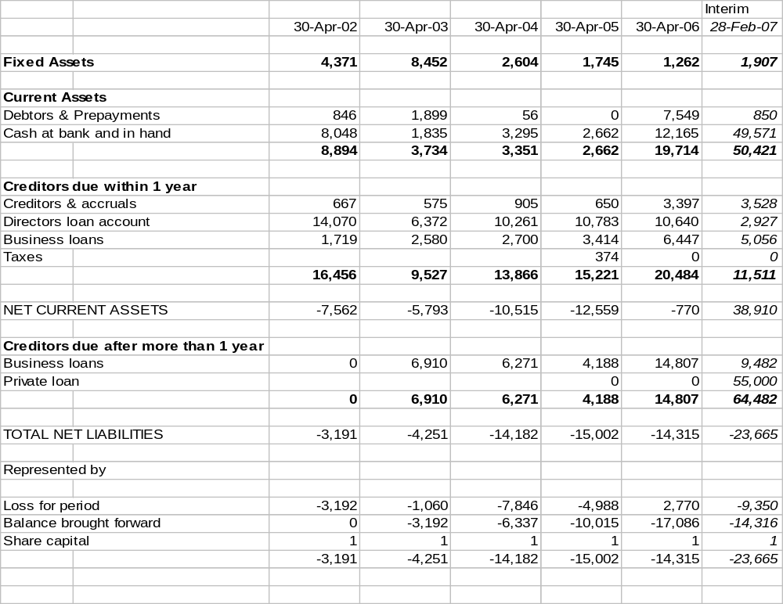

Profit and Loss statements - actuals

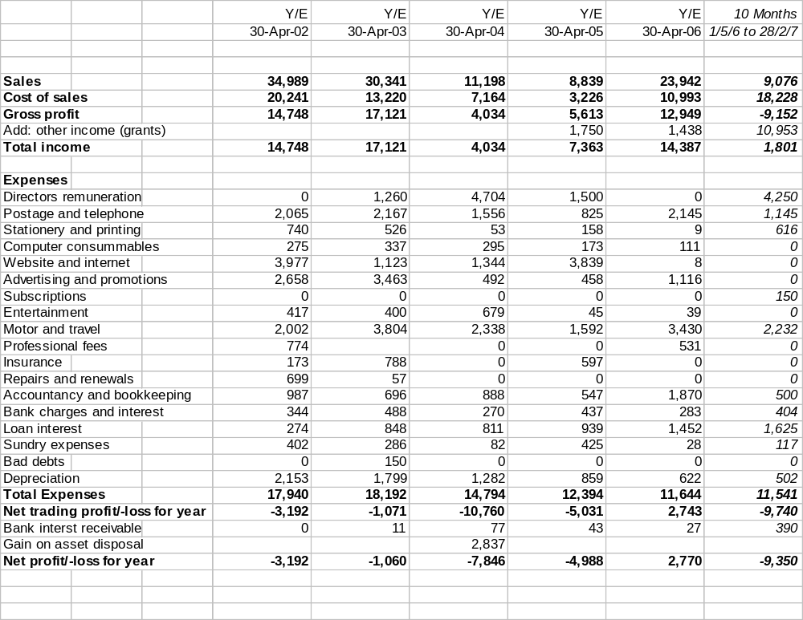

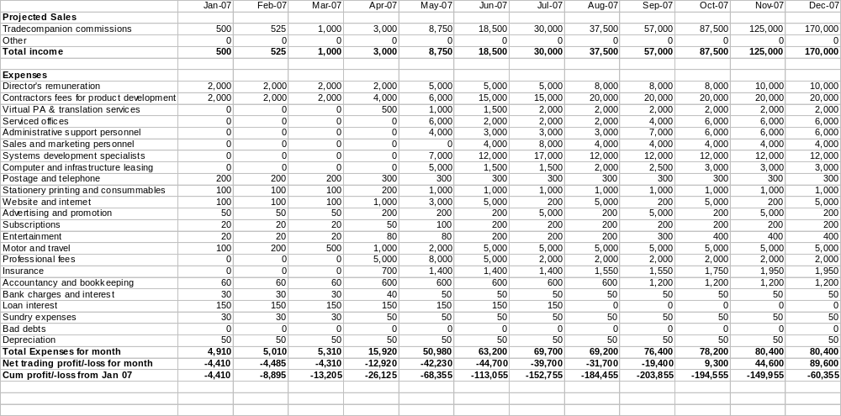Projected profit and loss statements to Dec 07

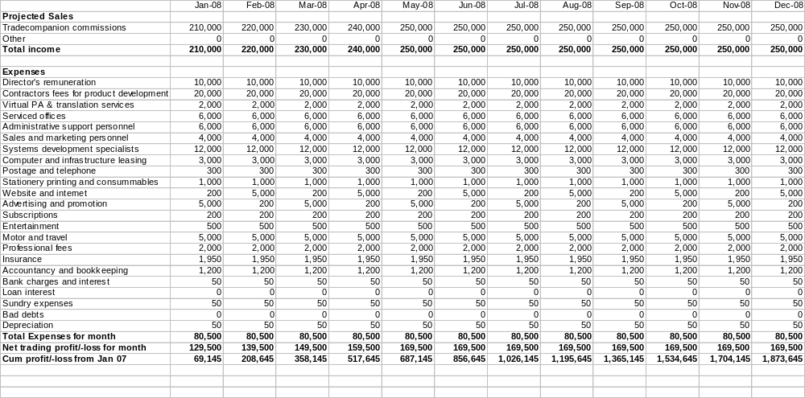Projected profit and loss statements, Jan 08 – Dec 08

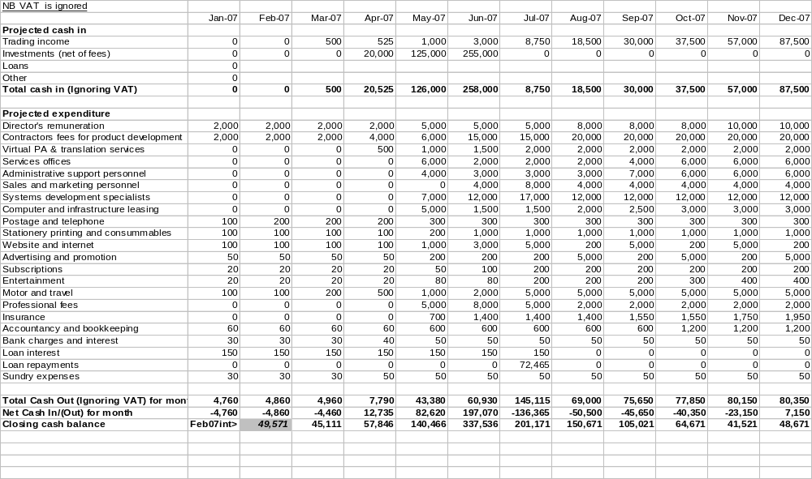Projected cash-flow statements to Dec 07

Projected cash-flow statements, Jan 08 – Dec 08
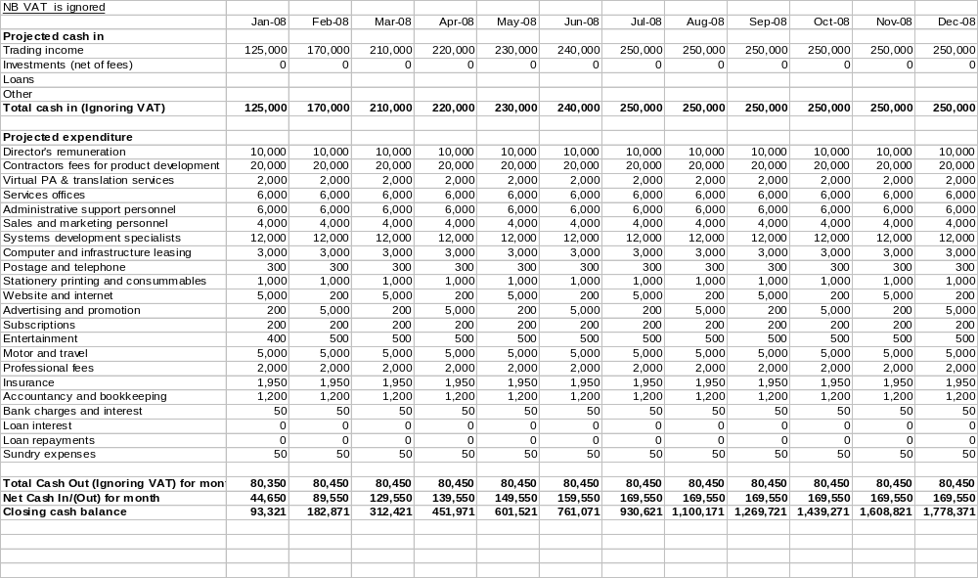

Projected Balance Sheet statements to Dec 07
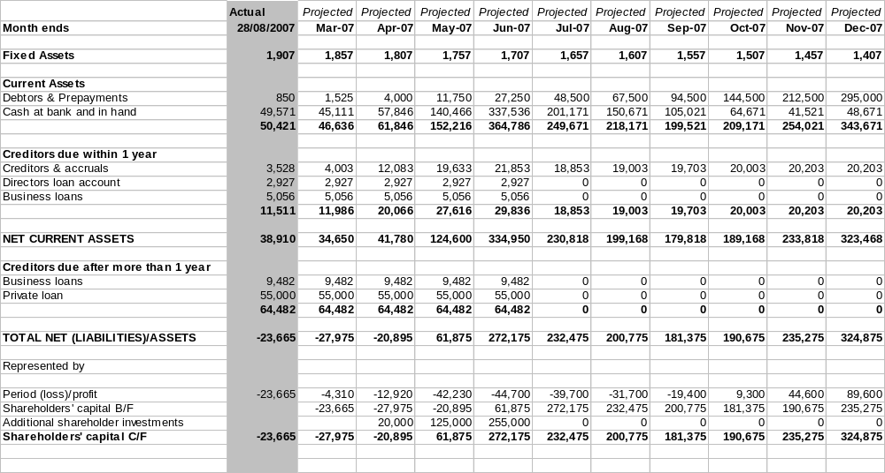

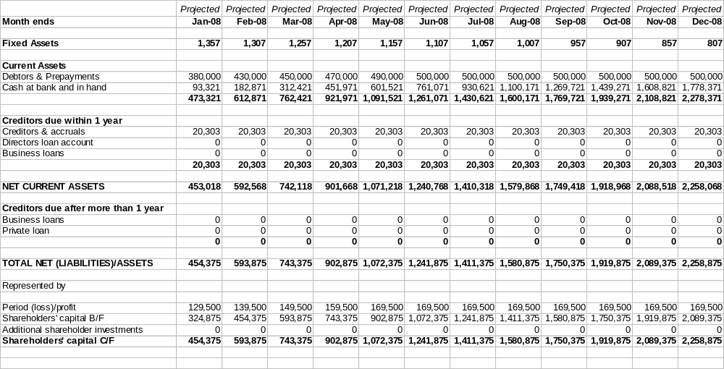Projected Balance Sheet statements, Jan 08 – Dec 08

SECTION 3 – STATUTORY COMPANY INFORMATION

Name: | Scalper Limited
Date of incorporation: | 11 April 2001
Place of incorporation: | England and Wales
Company’s registration number: | 04198908
Registered office: | 28 Devonshire Street Keighley West Yorkshire BD21 2AU
Authorised share capital: | £1,000
Amount: | £1
Divided into: | 1,000 ordinary shares
Issued share capital: | 1 ordinary share
Registered shareholders: | Franco Dimuccio
Director: | Franco Dimuccio
Secretary: | Glenn J Wrighton & Co
Accounting reference date: | 30 April
Auditors: | Glenn J Wrighton & Co
Mortgages and Charges: | None

SECTION 4 - PROCEDURE FOR APPLICATION

APPENDIX – MATERIAL CONTRACT

My (Steve Lowe) headline notes follow – clearly Cobbetts need to be in charge of this section – in consultation with BGC/Franco:

Note that in my view it is probably in Scalper’s commercial interest to keep exact numbers secret, as this is market information that could be very valuable to a competitor.

Key points relating to the distribution agreement:

- Prior to April 07, the agreement was operating on an informal basis
- Formal agreement signed April 07
- BGC to market Tradecompanion
- BGC to endeavour to handle as much of any emergent day-to-day customer support issues as reasonable
- Scalper to provide back-up support as necessary
- Scalper to earn from each Tradecompanion client, a commission based upon their business through the product, which recognises that both its and BGC’s commissions charged to each client will have to reduce as they complete greater volumes of business
- BGC and Scalper endeavour to protect each other’s business interests by recognising the commercial confidentiality and sensitivity of the trading information and intellectual property attaching to the agreement
- Each party is required to give the other 6 months notice of termination of the agreement apart from in exceptional circumstances as detailed
- The full agreement is a commercially sensitive document, which can be made available for examination upon special arrangement.

APPENDIX: KEY ENTITIES

BGC FX (www.bgcfx.com)

BGC Partners LP (Named after B. Gerald Cantor) was spun off of Cantor Fitzgerald in 2004. BGC Partners L.P. is a leading inter-dealer broker providing integrated voice and electronic services to wholesale market participants worldwide. BGC FX is a wholesale broking organisation committed to bringing value to its wholesale clients. The institutional trading and sales unit offers a fully comprehensive and competitive solution aimed at banks, financial institutions, fund managers, money managers, commodity trading advisors, and individuals
The service incorporates spot, forward FX, FX options, financial futures and precious metals transactions which are available 24 hours a day, from 20.00 (GMT) on Sunday through to 22.00 (GMT) on Friday, with trades executable via a combination of traditional voice and electronic communications, e.g. telephone, Reuters direct dealing, Bloomberg dealing and BGC's own internet trading portal. BGC offers hundreds of currency pairs which are available for trading in both major and exotic markets from AUD/USD to USD/ZAR.
BGC Partners Inc. the parent of BGC FX announced in February 2007 that it had filed with the US SEC its proposed IPO. Relevant websites include bgcpartners.com and bgcfx.com. Reference to Tradecompanion is made at bgcfx.com/pdf/TradeCom.pdf.

Currenex (www.currenex.com)

Founded in 1999, Currenex offers corporate and institutional buyers and sellers in the FX and money markets reliable, low-cost and secure electronic access to the $1+ trillion a day global FX market.
Currenex was acquired by State Street Corporation (NYSE STT) for $564 million in January 2007. One of Currenex’s key ‘white label’ partners is BGC FX

Tradestation (www.tradestation.com)

TradeStation Group, Inc. (NASDAQ GS: TRAD), offers the TradeStation platform to the active trader and certain institutional trader markets. TradeStation is an electronic trading platform that offers state-of-the-art “direct market access” (DMA) or “direct-access” order execution and enables clients to design, test, optimize, monitor and automate their own custom Equities, Options, Futures and Forex trading strategies. In 2006, TradeStation was named, for the second year in a row, Best Futures Brokerage and, for the fourth year in a row, Best Direct-Access Stock Broker, Best Direct-Access Futures Broker, Best Professional Platform and Best Institutional Platform, in Technical Analysis of Stocks and Commodities magazine. Tradestation has a current market valuation of $570 million.

Appendix: Franco Dimuccio

Date of Birth - 17/04/69, Nationality – British
Franco’s interest in Trading started back in the 90s with a friend who is now a successful Trader in the city.
He started trading his own account with a futures broker via a dealing room set up, with the aid of the Internet, in his bedroom, with all the dealing desks, such as Reuters etc., just like dealers have in London.
He started to trade on fundamental news. However he soon learned that to do this profitably one needed the infrastructure and knowledge support enjoyed by brokers in City firms as, by the time he was able to identify and act upon relevant fundamental news, its value had passed.
It was then that Franco learned how to be successful by trading on ‘technical analysis’, where the skill lies not in interpreting world events, but in how the various foreign exchange indices tended to move relative to each other over time.
At the time it seemed that all the packages he could apply to such technical trading were not very good, but after some extensive research he identified a Miami based company that offered the software tools he needed to write his own trading system.
Franco became very successful in programming for technical analysis and related systems and started to become known in Internet based FX trader communities.
By 2000 companies such as Esignal s were inviting Franco to speak at seminars and then Tradestation approached him and invited him to become as reseller for their new package, Tradestation 2000i and Franco set up Scalper Limited.
Tradestation 2000i has since become one of the leading packages for people to write bespoke FX trading systems with and is still used by many brokers.
Since starting Scalper, Franco’s clients have included, among others, IG Markets; Man Financial Markets; Merryl Lynch and Cantor Fitzgerald.
The tools first made available by Tradestation 2000i, in which Franco has become expert, have been applied and adapted to form the backbone of Scalper’s Tradecompanion.
Franco’s expertise and associated accomplishments encompass
- FX application programmer interface (API) technologies expert
- Expertise in mechanical FX systems trading
- Extensive associated programming language knowledge
- Respect across an extensive network of FX traders and software specialists in London, Europe, North America and Asia

Appendix: Roadmap to Dec 2007, as at April 07

This is the director’s current headline roadmap that has informed his financial forecasts.
As an evolving roadmap, it is liable to change.

Date | Milestone | Comments
Pre 2007 | N/A | History
Jan - March 2007 | Live test & soft launch Tradecompanion V 1.0 with BGC | Done - V 1.0 has Gain Capital feed & Currenex back-end
Mar – Apr 2007 | Develop V 1.1 | Done - V 1.1 = Currenex feed and back end connectivity
Mar – Apr 2007 | E-Forex article launch | 2 page spread – April Edn
Mar – May/Jun 2007 | Fundraising - £8M post money valuation | Preparation underway with: UKPE / Cobbetts / Bridge Hall
May 2007 | Launch program to develop V2.0 | Commission Indian subcontractors
May - Jul 2007 | Take on systems specialist | Have person in mind –£50-60K plus bonus?
May - Jul 2007 | Take on senior administrator & offices | To manage books, etc.  £35K, plus bonus
May - Jul 2007 | Continue refinement of V1.n series | Adding connectivity and meeting customer wants
May - Jul 2007 | Start handing V2 project over to specialist | Joint trip to Bangalore required
May - Jul 2007 | Push marketing with BGC | Possible joint trip to US
May - Jul 2007 | Add NEDs to Board | Need at least 2
Jul 2007 | Conduct revenue review | Above projected curve at 19 April – continuing to monitor
Jul 2007 | Prepare to list on UK PLUS Market in Aug-Oct. | Atlantic Law anticipate valuation on PLUS, subject to revised earnings estimates, to be £30-50M  Critical tasks – BGC agreement nearly done – Key Man – started.
Jul – Sept 2007 | Take on Sales and Marketing Assistant | To assist Franco with research, schedules, enquiry handling, customer hand-holding, etc. -£35K plus bonus
Jul – Sept 2007 | Take on Systems Assistant | Post-grad £25K plus bonus
Jul – Sept 2007 | Take on Admin Assistant | To handle growing workload - £20K + bonus
Late Jul – Early Oct 2007 | List on UK PLUS Market with assistance from Atlantic Law | £30M valuation based on current forecasts, to £50M if these are revised up.
Late Jul – Early Oct 2007 | Search for and take on 2 more NEDs | High powered names from the financial sector
Oct – Nov 2007 | Marketing push with BGC | Possible sales tour of European and NA institutions with BGC
Oct – Nov 2007 | Thorough strategic review | With expanded Board
Dec 2007 | 1st cashflow positive month of expanded Scalper plc | Per current cashflow forecasts

Appendix: Risks, Evaluation & Mitigation

A large part of the rationale for the current funding round is to help the business with its ongoing need to identify and then mitigate or manage the risks attaching to it.

Risks fall into one of four overlapping areas.

People and administrative – risks relating to:
- Franco as key man and Scalper’s current dependency upon him;
- Timely completion of administrative obligations as business picks up; and
- Employing staff and hiring contractors on appropriate terms.

Legal and contractual – risks relating to:
- BGC, honouring its contract and remaining keen to develop business with Scalper;
- Accidentally infringing the intellectual property and copyrights of other parties; and
- Protecting Scalper’s intellectual property and copyrights.

Market and competitive – risks relating to:
- Business uptake of Tradecompanion being slower than anticipated;
- Tradecompanion business losing our to competitively superior packages; and
- Regulation or market sentiment leading to a downturn in global FX trading.

Technical and operational – risks relating to:
- Software or systems failures, with Tradecompanion, in BGC or elsewhere;
- Unforeseen peaks in user-demand overwhelming the supporting infrastructure; and
- Future product developments realising poorer returns than anticipated.

Appendix: London and the global FX market

“London consolidates lead in global foreign exchange markets” By David Prosser

Published in The Independent newspaper: 24 October 2006
Britain's dominant grip on the global foreign exchange market has tightened to such an extent over the past 12 months that almost a third of the world's currency trading transactions now take place in this country.
Average daily turnover on the UK's foreign exchange market reached $1.1 trillion (£587bn) in April 2006, the last month for which figures are available from an annual survey by International Financial Services London (IFSL).
The trade body, which promotes the UK's financial services industry, said this represented 41 per cent growth on the same month in 2005. The UK expanded more quickly than any other foreign exchange market, with the whole of the world market rising in size by 38 per cent last year.
"The rapid growth in the volume of foreign exchange turnover over the past two decades reflects the continuing growth of international trade and expansion in global finance and investment," said Mark Maslakovic, the senior economist at IFSL. "The UK, and London in particular, is by far the largest global market for foreign exchange trading, well ahead of the US and Japan."
This year, deals transacted in London will account for 32.4 per cent of all foreign exchange trading, according to IFSL's analysis. The UK's market share is almost twice as high as the next biggest player, the US, which has 18.2 per cent of all currency trading. Japan, with 7.6 per cent, and Singapore, with 5.7 per cent, are the next most important currency exchange markets but lag considerably behind Western competitors.
The US and Japan have actually lost ground on the UK over the past two years, the IFSL's figures show, with their market shares slipping from 19.2 per cent and 8.3 per cent respectively in 2004. Britain's share has moved up from 31.3 per cent over the same period.
Mr Maslakovic said the UK had developed into the ideal centre for currency trading since Margaret Thatcher's newly elected Conservative government abolished exchange controls in 1979.
Until then, foreign investors were almost entirely prevented from buying sterling unless doing so would benefit Britain's balance of payments figures. UK residents, meanwhile, were not allowed to buy foreign currency for investment purposes, unless the purchases were funded with the sale of existing overseas assets. There were also tight restrictions on UK residents' ability to hold foreign currency in deposit accounts.
Analysts estimate that almost £30bn flowed out of the UK after Mrs Thatcher's decision to drop the controls. However, the liberalisation has subsequently enabled the UK to cash in on its geographical position as a bridge between the US, Europe and the Far East.
IFSL said the UK had a string of additional advantages as a centre for foreign exchange trading. They include: a large fund management sector; a large number of investment banks and brokers; easy access to global markets combined with a tradition of welcoming foreign firms; high-quality professional services; efficient telecoms infrastructure; and the use of the English language.
In addition, Mr Maslakovic said that while some domestic financial services companies believe the City of London is over-regulated, foreign currency traders' "perception [is] of a proportionate approach in the regulatory climate".

Appendix: Extracts from e-Forex Magazine, April 2007

Below is a ‘cut and paste’ of items from a .pdf document which in no way represents the high quality of the original print layout or pictures and it is presented here merely to convey the text content of the original article. E-Forex magazine’s Internet presence is located at e-forex.net. This article should be able to be accessed from the e-Forex website and has also been presented as BGC FX’s case study on program trading via its website at: bgcfx.com/pdf/TradeCom.pdf

Automated Trading from a chart with Trade Companion and BGC

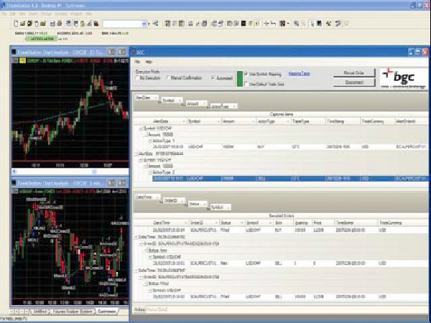
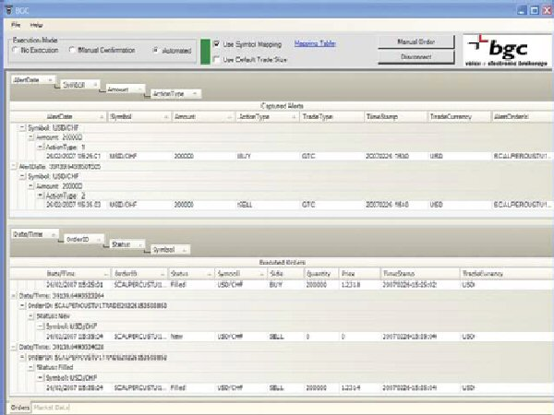

Automated trading has been around for approximately fifteen years and is certainly nothing new to the financial markets, but with the growth of liquidity and the accessibility of tight pricing, foreign exchange more than anything has become both more attractive and readily available to today’s finance savvy investor. This has created an explosion in growth within the foreign exchange automated trading market which looks set to continue. e-Forex talks with Franco Dimuccio from Trade Companion, an authorised reseller of Tradestation Technologies, which has linked up with the liquidity provider BGC, about their latest Automated trading and API solutions for the foreign exchange industry.
Can you tell us about Trade Companion?
Trade Companion is an automated trading tool designed to help assist FX market participants automate their strategies into a multi-bank platform and, is designed to be a flexible product which can be used to meet the needs of institutional and retail clients. It has the ability to provide fully automated trading signals or semi-automated signals that allow the client to decide whether or not to send or allocate an order to managed accounts, and is very easy for an individual trader running his own portfolio to use. Trade Companion gives the retail trader similar liquidity and speed to that that institutional players already enjoy. Typically, clients will have their strategy back tested and be happy to start trading but only then discover that the pricing they are receiving is too punitive, thus taking away an enormous chunk of their potential gain through extra spread and costs. So rather than link up to a single bank proprietary platform, Trade Companion has developed an API interface which routes into our multibank provider BGC.
Why is pricing such an important issue?
It’s important to explain a little about the multibank providers here. Whilst they all compete with each other offering competitive solutions, this is not the overriding factor in choosing one. The common mistake by most is to confuse multibank providers with portals. The portals vary in terms of functionality, speed and contributors. Some banks will price in one portal but not another, thus affecting liquidity and spread. This is a key factor but not the full story. Some banks also price providers differently through the same portal dependent on other factors like the relationship or flow.
Why did you choose BGC as a partner?
BGC fulfilled everything Trade Companion was looking for. Their platform is the one of thebest we have seen to date, not only dealing with all of the above but also offering comparatively large trade sizes. This is coupled with other factors like clearing through CLS, acting as the prime broker directly to the network of banks my clients need to access, the entire margin being housed in one place, and no give up process as the client has BGC as the counter party on every trade.
In addition to this, Trade Companion supports multiple strategies on multiple currency pairs. The back office functionality of BGC also supports this functionality, allowing the allocation of trades after a bulk trade has been executed, thus enabling money managers to concentrate on their strategy and spend less time allocating trades or looking after back office functions.
Does integrating the technology pose any problems for client?
No, Trade Companion along with BGC have integrated all the technology involved. This gives not only the institutional investor but also the “long-ignored” retail investor or smaller company the access they need to enter the automated trading arena without the expensive costs of programmers and IT integration. All are able to seamlessly execute orders generated by their TradeStation strategy without any programming! Tradecompanion is able to Automate and execute your strategy written in TradeStation, Excel, Wealthlab, Fix, C++, Visual Basic, .NET or any other proprietary platforms on one account.
Can you illustrate some of the key features of Trade Companion?
Trade Companion supports multiple strategies on multiple currency pairs. Trade companion also allows the client to be given the signal that a trade needs to be done but the client can decide whether or not to send the order.
How have clients responded to the product?
Being the first developer and reseller in the UK means that our company has a wealth of experience integrating with Tradestation2000i and 8. We’ve seen high demand from clients which has led to us developing the automated interface as well as the feed from multiple banks into Tradestation 2000i. Steve Pryor, Director of BGC Foreign Exchange said, "We want to give our clients the ability to choose which front end dealing platforms they trade on whilst providing them with competitive pricing and clearing services. Trade Companion is an excellent product that will help us to achieve this and is the first charting package available on our growing suite of FX products."
End (of article)

Appendix: End-user marketing
This embedded document is part of the marketing literature being prepared by one of Tradecompanion’s early customers.
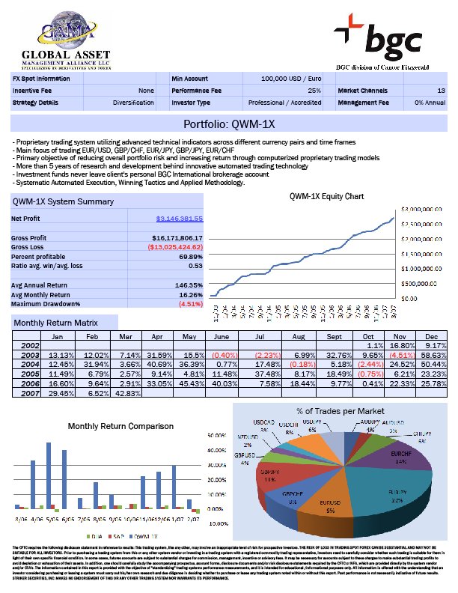
This customer is currently auto-trading multiple accounts through BGC with the aid of Tradecompanion: a feat that it would otherwise find impossible.

This customer is currently auto-trading multiple accounts through BGC with the aid of Tradecompanion: a feat that it would otherwise find impossible.

See key entities listing in Appendix
Numerous references found via a search of the Internet identify the global FX market as, bar, the largest, in terms of the value of daily transactions conducted. See also the appendix: London and the global FX market
Before BGC can allow new trading clients to trade via its systems it first has to ensure they pass stringent anti money-laundering and other compliance checks.
A summary of Scalper’s current roadmap is appended.
See also text of e-Forex article, appended, in which the product, Tradecompanion, is discussed at length.
See key entities appendix – Currenex.com “Currenex connects more than 70 global banks to a superior electronic trading network”.
‘Front-ends’ here refers to the software that traders use to analyse FX market information so as to determine whether or not to effect their own FX trade. In turn, ‘their own FX trade’ being their commissioning of a purchase or a sale of a given amount of one specific currency for an agreed amount of another specific currency.
See key entities appendix – and Tradestation.com. Although Tradestation’s Internet home page refers to its ability to fully automate strategies, this functionality is not comparable to that of Scalper’s Tradecompanion.
See metatrader4.com; wealth-lab.com and signal.com. See also e-Forex article text appended.
eSpeed.com – “Thousands of traders at hundreds of global financial institutions conduct over $45 trillion of transactions annually in our multiple buyer/multiple seller markets.”
Taken from a State Street Corporation press release upon its acquisition of Currenex - see key entities appendix - for $564million cash in January 2007. See also, ‘London and the global FX market’, in the appendix.
The margin in this case is the gap between the selling price and the buying price of any currency relative to any other, being offered by the market maker. The term ‘Spread’ is also used instead of ‘Margin’ .
$0.0001 different between what they are prepared to buy or sell a currency for relative to another currency
In BGC’s case, high value institutional and independent ‘wholesale’ traders. See the appendix on end-user marketing, which shows how an early Tradecompanion customer is already exploiting its capabilities.
Tradecompanion is just one of many different tools and value added services that BGC offers to win business. Although Scalper and BGC anticipate that Tradecompanion will help BGC defend existing and win new FX trading customers, much of its business is and will continue to be conducted without the use of this product.
There is no singular authority capable of auditing the global FX market but a growing number of ‘expert’ commentators, as evidenced via a google search of the Internet, appear to endorse this opinion.
On the Internet at e-Forex.net. The article is also reproduced on BGC’s FX website.
Appended
If the pre-money valuation is £7,500,000 prior to any additional funds being invested into the business, a successful £500,000 investment round should result in £500,000 less the cost of fundraising being injected into the business and a ‘post-money’ valuation, provided all else remains the same, of £8,000,000.

